SET 1

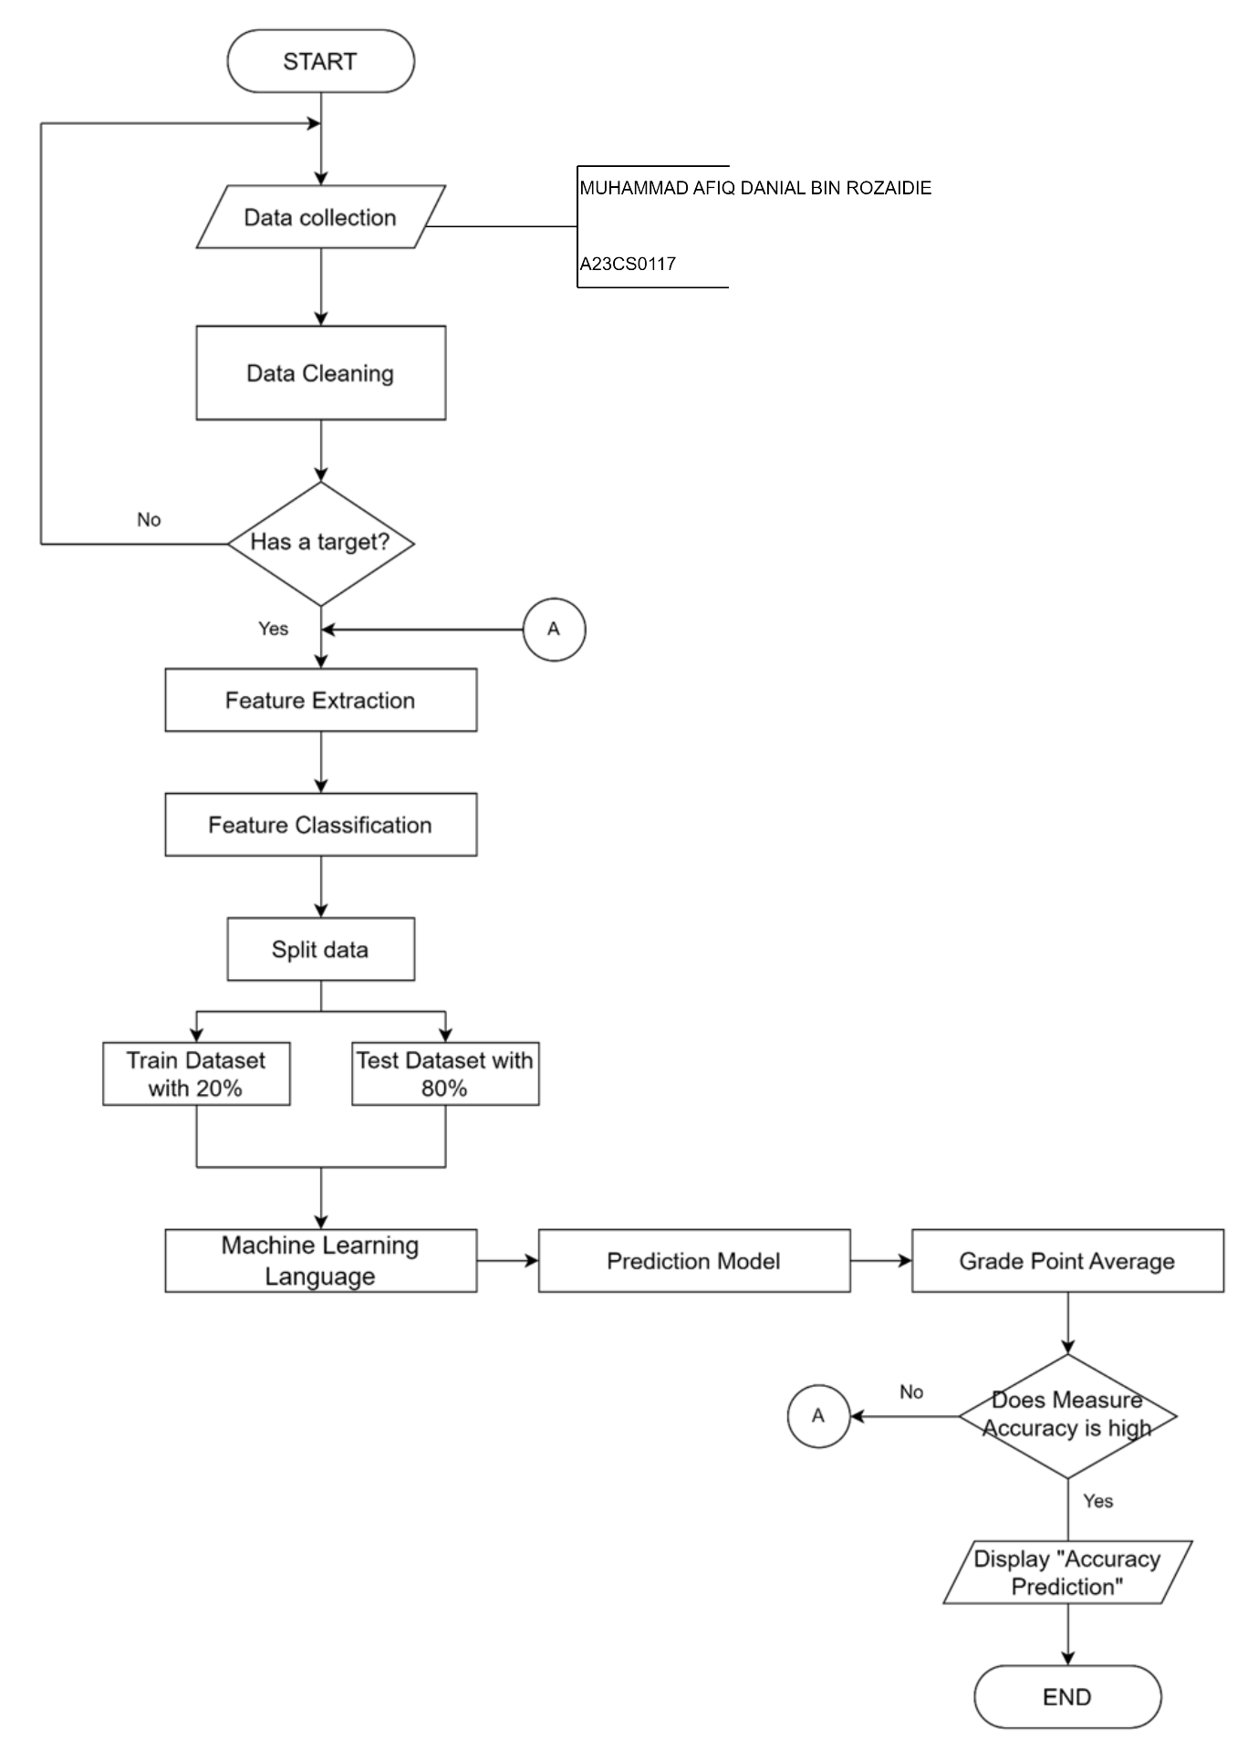

SET 2
1. Start
2. deposit = 0.10 // MUHAMMAD AFIQ DANIAL BIN ROZAIDIE A23CS0117
3. Get the name, duration, package, customer_Type
4. if customer_Type = Regular
4.1 discount = 0.10
5. else
5.1 discount = 0
6. End if
7. if package = 1
7.1 price = 150
8. else
8.1 price = 250
9. End if
10. price = rental * duration
11. deposit_Payment = deposit * price
12. total_Discount = discount * price
13. balance = price – total_Discount
14. Display name, deposit_Payment, total_Discount, balance
15. End

SET 3
1. Start
2. product = 1 // MUHAMMAD AFIQ DANIAL BIN ROZAIDIE A23CS0117
3. Enter num
4. while (num != 0)
4.1 product = product * num
4.2 enter num
5. end while
6. if (product % 4 = 0 && product % 5 = 0 && product % 7 = 0)
6.1 display product, “is multiple of 4, 5 and 7”
7. else if (product % 4 = 0 && product % 5 = 0)
7.1 display product, “is multiple of 4 and 5”
8. else if (product % 4 = 0 && product % 7 = 0)
8.1 display product, “is multiple of 4 and 7”
9. else if (product % 5 = 0 && product % 7 = 0)
9.1 display product, “is multiple of 5 and 7”
10.else if (product % 4 = 0)
10.1 display product, “is multiple of 4”
11.else if (product % 5 = 0)
11.1 display product, “is multiple of 5”
12. else if (product % 7 = 0)
12.1 display product, “is multiple of 7”
13. end if
14. Stop

SET 4
